Project Design Phase
Proposed Solution
Date | 9 September 2026
Student Name | Burada Laxmi Sai Priyanka
Project Name | Licensed Software Installation Request through Service Catalog
Maximum Marks

Proposed Solution
The proposed solution is a ServiceNow-based Licensed Software Request Management system. A Software Installation Service Catalog item allows employees to submit requests for approved licensed applications required for their work. The Service Portal provides employees with a simple and guided way to access the software request functionality.
Catalog variables capture the required request details, while Catalog UI Policies and Client Scripts control form behavior and display relevant fields dynamically. Flow Designer automates the approval process, validates the request, and creates fulfillment tasks for the Software/IT Support Team. The system also supports license tracking, request status updates, notifications, and completion of the installation process.

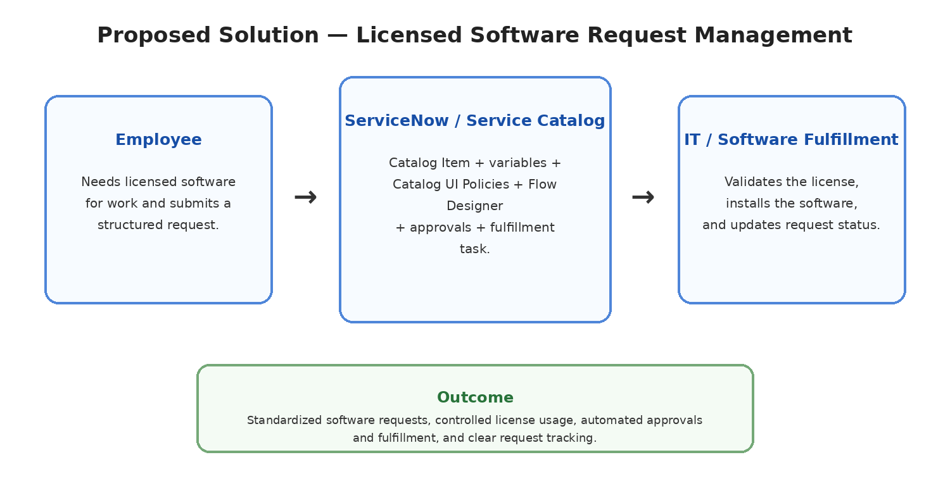
Figure 1: Proposed solution representation.

S.No. | Parameter | Description
1 | Problem Statement | Employees need a simple and structured way to request installation of licensed software while ensuring that license availability and approvals are properly controlled.
2 | Idea / Solution Description | A ServiceNow-based Licensed Software Request system using the Service Catalog for guided request submission, approval, license validation, and automated fulfillment.
3 | Novelty / Uniqueness | Combines Service Catalog, dynamic UI Policies, Client Scripts, approval automation, license validation, Flow Designer, and Software Installation Tasks in a connected workflow.
4 | Social Impact / Customer Satisfaction | Makes software requests easier for employees, reduces manual coordination, improves request accuracy, supports compliance with software licensing, and provides better status visibility.
5 | Business Model / Revenue Model | Internal organizational IT service solution; no direct revenue model is required. The main value is controlled software usage, faster fulfillment, and reduced administrative effort.
6 | Scalability of the Solution | Can be extended with additional software categories, automated license inventory checks, department-based approvals, notifications, dashboards, integrations with endpoint management tools, and advanced automation.

